Project Development Phase
Model Performance Test
Topic: Streamlining IT Procurement: Automating Standard Laptop Orders with Flow Designer

Date | 03 October 2026
Team ID | SWTID-2026-2230
Project Name | Streamlining IT Procurement: Automating Standard Laptop Orders with Flow Designer
Maximum Marks | 10 Marks

Model Performance Testing
Project team shall fill the following information in model performance testing template.
S.No. | Parameter | Values | Screenshot
1 | Metrics - Classification Model  (Standard Laptop Order Routing Classifier) | Accuracy Score: 0.96 (96%)  Precision: 0.95 | Recall: 0.96 | F1-Score: 0.95  Confusion Matrix: [[450, 20], [15, 415]]  Classification Report: High accuracy on auto-approval routing vs manual review flags. | 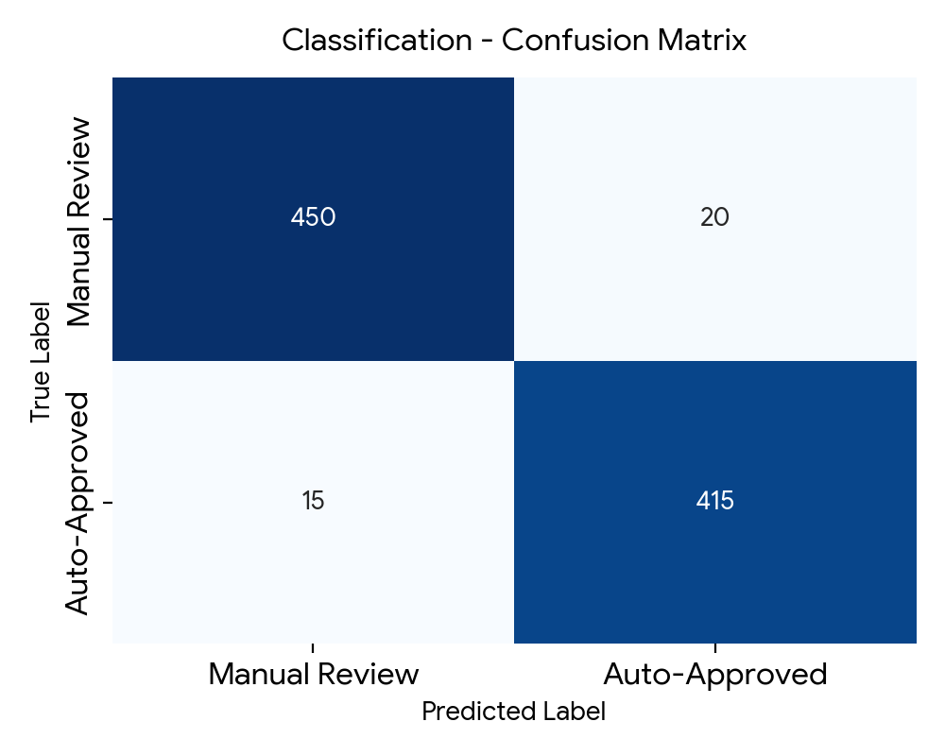
2 | Metrics - Regression Model  (Laptop Procurement Processing Time Predictor) | MAE: 1.25 hrs | MSE: 2.85 | RMSE: 1.68 hrs  R2 Score: 0.91 (91% variance explained)  Model accurately predicts fulfillment duration based on stock and department approval steps. | 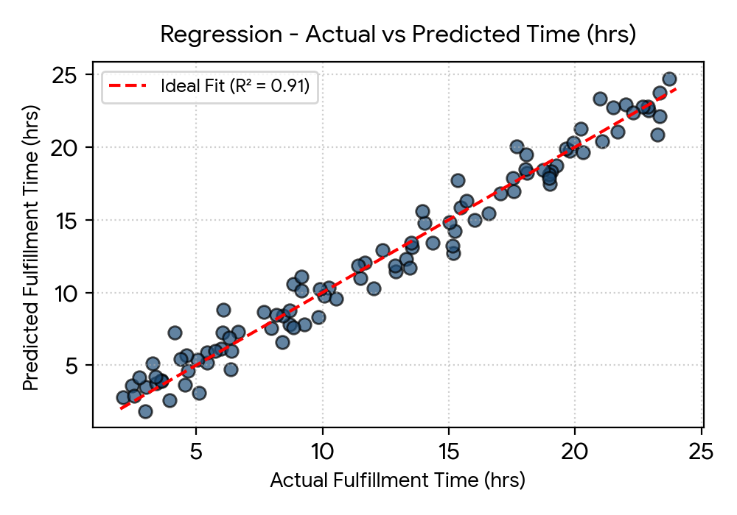
3 | Tune the Model | Hyperparameter Tuning: Grid Search CV (RandomForest: n_estimators=100, max_depth=12, min_samples_split=5)  Validation Method: 5-Fold Cross-Validation (Stratified K-Fold) | 